Family Fishing “Event in a Box”
Overview

It has become clear that for the mission of Trout Unlimited to survive, we must bring in more diversity, youth, and the community into our membership and into our conservation agenda. Stormwater runoff is becoming a bigger problem. More and more impermeable surface is having a negative impact on our coldwater streams. The public at large needs more information about what they can do as individuals, to protect our coldwater resources. Chapters are looking for ways to educate their neighbors and bring the message of TU to their communities and to their local governments.

To this end, we have put together a “Family Fishing Event in a Box.” This is a step by step plan for hosting a family fishing event in your community. It will bring people out to have fun, learn, and bring new partnerships to TU’s conservation mission. For best results, partner with other organizations to put on this event.

The goal is to list ideas, give you templates, and stimulate your own creativity.

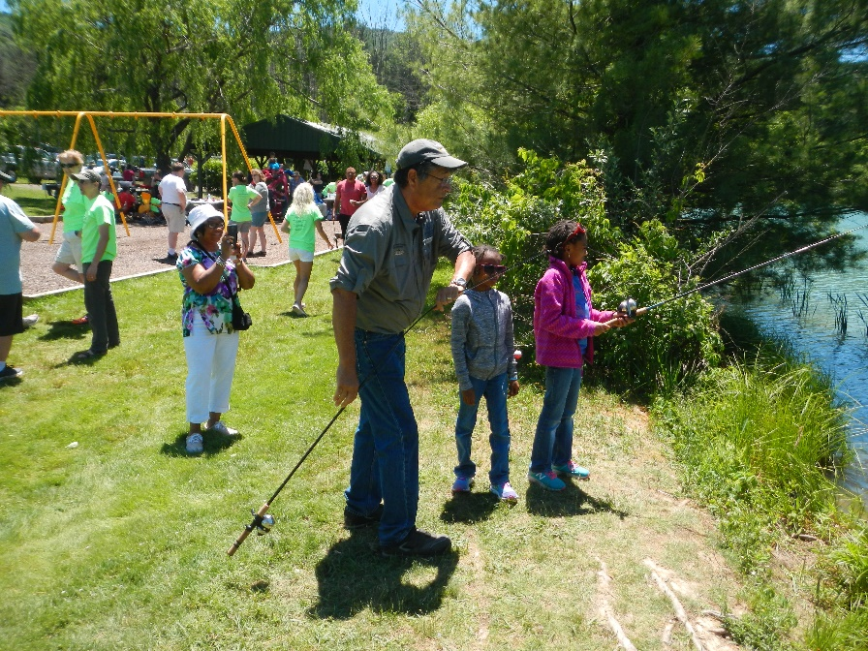

Suggested Resources

An actual event that used the templates and ideas below, successfully engaged over 300 people from the community and cost the chapter $1200.

Grant sources:

The League of Women Voters of Pennsylvania, Julie A. Kollar, Project Director, Water Resources Education Network (WREN). juliekwren@veroizon.net www.sourcewaterpa.org
Grant deadlines, mid-March

Western Pennsylvania Conservancy & Dominion, Watershed Mini Grant Program, Kelly Horrell, Watershed Conservation Program Administrator, 724-471-7202 ext. 5100, khorrell@paconserve.org Grant deadline mid-December.

Foundation for Pennsylvania Watersheds, Convening Grants Program, Branden S. Diehl, Grant and Project Consultant, (814) 669-4244 ext. 303

Donation Sources:

Townships (e.g. can help with PR to residents, funding $, and volunteers)
Local Conservancy (e.g. volunteers or funding $)
Local Business Bureau (e.g. signage and other PR for event)
Local non-profit organizations with similar goals (Rotary, Legions, Veterans programs)
Local grocery stores (e.g. often give $25 gift cards;) (take a letter and brag sheet in to store)
Local government officials (e.g. flyers and other PR)
Bait shops/Fly shops (e.g. donate worms, gear, prizes)
PA Fish & Boat (especially fishing rods for loan)
Local restaurants (e.g. food donations)
Publicity sources: newspaper, radio, websites for local community activities (often free!)
Local office equipment stores (e.g. poster board)

Miscellaneous Resources:

- Nationalgetoutdoorsday.org
- GetOutdoorsPA.org (PATU is a Partnering member; contact us to utilize many planning and partnership resources available on this site.)
- Trout in the Classroom manual for Press Releases idea.
- Water Words that Work; www.WaterWordsThatWork.com
- PA Fish & Boat: Instructor course for license exemption event; handouts; partnering.

Below you will find two different styles of templates for letters requesting donations to sponsor the event.
Whether mailing the request or giving it in person (which is very effective with grocery stores), it is a good idea to include a page “bragging” about your chapter accomplishments. Grocery stores are often authorized to give a $25 or $50 gift card on the spot if you go to the store in person. One store gave 5 cases of bottled water on the spot.

Your letterhead here
(Date)

Dear Community Member:

The _______________ Chapter of Trout Unlimited (___TU) will be hosting a _____ Family Fishing Event_____ at the pond of the __________ in __________ on _________ from _________p.m. The event will feature family-friendly activities including fishing, knot tying, bug identification, hands on conservation lessons, free food, games, and more.

___TU is requesting donations in the form of a gift card to purchase food for the event. Please consider providing a contribution to help make our event successful. ____TU has adopted the following sponsorship policy to recognize donors to the event:

Donations of $50 or more:

- Recognition in Trout Unlimited – ____________ Chapter promotional publications for the event (electronic newsletter, social media, website)

Donations of $100 or more:

- Recognition in Trout Unlimited – ___________Chapter promotional publications for the event (electronic newsletter, social media, website)
- Sponsor logo displayed on promotional materials including t-shirts and event flyers

Donations of $200 or more:

- Recognition in Trout Unlimited – ____________Chapter promotional publications for the event (electronic newsletter, social media, website)
- Sponsor logo displayed on promotional materials including t-shirts and event flyers
- Activity booth sponsorship for event day with sponsor acknowledgment and logo displayed at booth.

Thank you for considering our request to sponsor this event. Please submit any donations to my attention at___________________. The deadline for donations is ________. If you have any questions, please do not hesitate to contact me by phone at (____________or my e-mail at ________________________.

Sincerely,

Community Outreach & Youth Education Chair, SCCTU
Ph#______ and e-mail ____________
Footer: The ____ Chapter of Trout Unlimited is a tax exempt 501 (c) 3 nonprofit organization.
Your letterhead here
Date

Name & address

Dear _________,

The ________ Chapter of Trout Unlimited (___TU) is inviting you to partner with us to plan a community event at which there will be family fishing fun, outdoor games, food, and educational activities related to conservation and outdoor recreation.

This event will be held at_____ where chances are good that the kids will catch a fish or two. Our chapter volunteers will provide fishing instruction and assistance and will lead the conservation and educational outreach efforts. There is a non-refundable charge of $____to rent the large pavilion for the event. Additionally, there is a charge of $___ to rent a large grill. Our plan is to serve hotdogs as they are quick and easy and adored by most kids and their families. We have found providing food to be a good draw and tends to draw more people to an event.

Our chapter is asking you to help us make this family friendly event possible by contributing to the cost of facility rental. We have already received confirmation of donations from these other community members and businesses_______________. (Or: We are in the process of making similar requests of these community members and businesses to help with other costs associated with hosting this event.)

Please let me know how much you are willing to contribute to this exciting, fun, and educational opportunity for children and families in our community. I hope to hear from you by ____________ as renting the pavilion at ___________ should be done at the earliest opportunity.

If appropriate: We appreciate all the chances we have had to partner with your organization. This would be one more opportunity to join forces and provide some outdoor family fun for our community.
Respectfully,

__________Community Outreach & Youth Education chair, ____TU
Ph.# & e-mail address

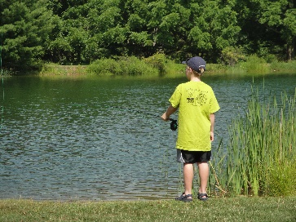
Footer: The ______chapter of Trout Unlimited is a tax exempt 501 (c) 3 nonprofit organization.

Activities/Stations
Consider having several activities so you can cover a wide age range from toddler to adult.

Fishing Station – One spot for handing out and collecting rods/gear/
Have permit to fish without a license from PA Fish & Boat
Person in charge - ________ Volunteers ________________________________________________

Casting Practice – 2 rods for adults, 1-2 for little kids + 4 hoola hoops & “fish on a stick”
Person in charge – __________Volunteers – ____________________________________________

Knot Tying – Table, hand-outs, corks/string, regular monofilament with blunted hooks
Person in charge – ___________________Volunteers – ____________________________________

Bug Identification/Nature Exploration – Table; aquatic insects; scavenger hunt
Person in charge - _________________Volunteers - ______________________________________

Little Kids Lawn Fishing Games – 3 activities (magnet fishing, paper craft, coloring fish picture)
Person in charge – ____________________Volunteers – ________________________________________

Stormwater/Conservation for the Family – Enviroscape
Person in charge – _________________Volunteers – ____________________________________________

Kayaks – Local kayak organization or shop – kayak rides
Person in charge - ______________

Other Activities – Games; Have some bait fish in a bucket with an aerator, for the little kids to touch.
Person in charge - __________________Volunteers - ________________________________________

Welcome Station – Goody bags put together and distributed to families on their way home. (PA Fish & Boat a good source of handouts, along with TU national tool box. E.g. Stream Explorer back editions.)
Person in charge - ________________Volunteers - _______________________________________

A Mascot – A local mascot from a high school or radio station or sports team. Or purchase your own costume and get someone to wear it. The mascot walks around and the family takes photos of their children with the character. We had “Tony the Trout” hand out Swedish Fish.

Food Station – Free hot dogs, chips, juice boxes, water, cookies (keep it simple)
Person in charge – __________________Volunteers, to cook and distribute – ____________________
(Consider township council members do the hot dog cooking. They loved having their photo taken cooking hot dogs for the community.)

Suggested Food List:
Hot Dogs
Snack bags (chips)
Water (either individual bottles, or a large jug filled with water and cups available)
Drinks for the kids (reduced sugar)
Relish packs (ketchup, mustard, relish)
Brownie bites or Cookies
Paper plates
Napkins
Plastic forks, spoons, knives (to spread relish)
Ice (lots of it)
Hand wipes or hand sanitizer
Disinfectant wipes (for tables, etc.)
Paper towels
Table cloths
Aluminum foil
Misc. grilling tools
Coolers
First Aid Kit

Depending on location, you will need:
Tables
Chairs
Pop-up tents
Trash/recycle receptacles
Porta Potty

Press Release Example
A press release should include contact info., Headline and subhead, event summary, be clear, concise and tell What, Who, When, Where, Why, How. No more than one page.

Your Letterhead here

FOR IMMEDIATE RELEASE CONTACT INFORMATION
Date Name
Town President, _______ Chapter of TU
Address
Phone:
Family Friendly Fishing Events
Learn what it takes to keep _______Creek healthy while learning a few fishing skills.
The ______ Chapter of Trout Unlimited (___TU) and ______ (Partner) will be inviting the community to a Family Fishing event. The event will __________________________ (describe your goals here).
Date
Time -
Location -
Address -
RSVP requested
___TU will teach families to fish. All equipment will be provided. No fishing license required for that day and location. The (partner) will be providing ……
The first 20 families will receive a free seedling that can be planted in their backyard. Free hot dogs, chips, and drinks will be served. Fly casting lessons will be provided as well as aquatic insect identification of the insect life that inhabits _________. There will be representation from ______ Township.

For more information about the _______ Chapter of Trout Unlimited activities, visit their website at www.chaptertu.org
The mission of the ________ Chapter of Trout Unlimited is to conserve, protect, and restore _____________ coldwater fishery and watershed.

The __________Chapter of Trout Unlimited is a tax exempt 501(c) 3 non-profit organization.

Publicity Worksheet
Consider a wide variety of places to get the word out with fliers, posters, public announcements.

Local School Districts
Private Schools
Youth Service Bureau
Leadership Academies
Conservation Districts
Conservation Organizations
Public Library (One library agreed to put a small page notice in each book that was taken out.)

A simple Flier can be produced in Word or Publisher or even Power Point. Keep it simple.
An example follows. Fliers should include pictures of people enjoying themselves! Cute, happy kids get the most attention on fliers.

JOIN THE ___ CHAPTER OF TROUT UNLIMITED
FOR AN AFTERNOON OF FREE OUTDOOR ACTIVITIES
At the
FAMILY FISHING PICNIC
CATCH A FISH – ALL TACKLE PROVIDED
PRACTICE KNOT TYING & FLY CASTING
LEARN TO IDENTIFY BUGS & OTHER WILDLIFE
FREE FOOD - GAMES - SCAVENGER HUNT
(NO FISHING LICENSE REQUIRED FOR THE EVENT)

SATURDAY, JUNE__, 201_ - 12 – 4 PM

LOCATION …………………………..
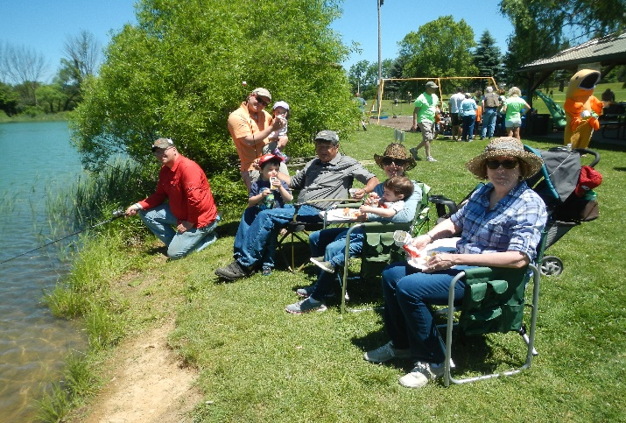

(Include logos of sponsors here.)
Day of Event Set Up and Clean-Up
*Site hosts: ____________ & _______________ (assistants: ___________, ______________)
*Important to have one or two people whose only job is to see that people have what they need.
Set-up Volunteers: (need @ 7 - 10)
Arrive for set up – 10AM
Volunteers: _______________________________________________________________

___ set up tents (TU has 5 pop-ups & 1 large tent)

___ clean grills. Need wire brush, paper towels, ________

___ set up/clean tables

___ chairs set up (personal chairs brought)

___ hang banners (____TU chapter Banner, other banners

___ trash cans/re-cycle/bags ready

___ welcome table –sign-in; hand-outs, etc. put in bags; first aid kit (+ sun block, bug spray)

___ station signs positioned

___ directional signs located on approaching road

___ set up each station

___ set up fishing gear

___ Caution tape if necessary at some hazardous area

___ food & ice in coolers filled

___ first aid kit in position

___ photo waiver forms - You might also cover your basis by posting a sign at entrance stating:
“You are entering an area where the _________ is conducting an event. Please be advised that you may be filmed as part of the audience and by entering these grounds, you are granting _________ and their affiliates the right to broadcast your likeness, appearance, name, and/or voice in any media, worldwide, in perpetuity.” Thank you and enjoy the _____________.
Follow=up

- Thank you notes to donors, volunteers, partners
Note – keep good address records to make follow up notes easy.
- Follow up on any families/individuals who might have signed up for membership or more information, etc.
- Have a “de-briefing” with all volunteers to discuss what went well and what could be done better. At least ask for debriefing via e-mail, from your volunteers.
- Keep good expense records
- Keep good donor records

Project Timeline
Get Outdoors Family Fishing Event

February – April
Establish planning team and committees
Determine key elements of event
(e.g. how many people anticipated?)
Develop and send out donation/partner request letters
April
Partner stations arranged
Special recognitions. Partners. Line up
Confirm set-up/tear down times
March – May
Develop site-specific timeline (day-to-day deadlines; who is responsible)
Interaction with partners
(identify & clarify roles)
(identify donations; goods 7 services)
Secure volunteers to assist on event day; train/orient to assignment
Site mapping and layout
(signage)
Food & Beverages lined up/specific
Comfort stations (adequate?)
Safety & First Aid
First Aid Station (CPR trained person)
Emergency contacts available (police, EMT)
Welcome Station Plan
May – Advertise event & Assign one person to be in charge of each station
Finalize marketing/public relations schedule and strategy
Media line-up
Media kit (press releases, fact sheets, etc.)
Photographer/videographer
Local news & TV
Radio public service announcements
Press table at event (prepared press releases, place to conduct interviews)
Community outreach
Identification & invitation of special guests
Post information on community calendar
Fliers and posters
Signs & banners
Public comment box

June – Make site visit and have mock-up of all stations/activities/signage, prior to event

