Women’s Fly Fishing Introduction “Event in a Box”
3 -hour event

In order to carry on the mission of Trout Unlimited, we must expand our membership base to include more diversity and youth. TU has been a male dominated organization since its beginning in 1959. Today, we recognize that in order for the organization to thrive, we must actively seek out and welcome women from our communities to join the coldwater conservation effort. Women can bring fresh perspective, a varied skill set, and valuable leadership to local chapters and councils.

To this end, we have put together a template for attracting women who have expressed an interest in fly fishing and an overview of what is involved. This 3-hour event will introduce women to the various aspects of fly fishing. It would also introduce them to the local TU chapter and conversely, the local chapter could “fish” for women volunteers, new active members, and leadership potential.

The goal of this packet is to provide ideas and templates and to stimulate your own creativity.

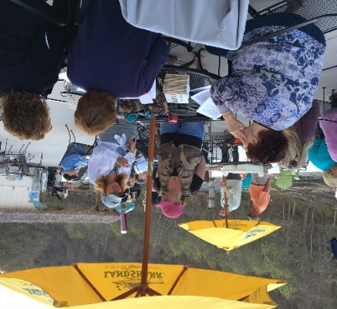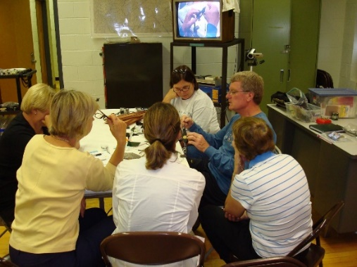
Women’s Introduction to Fly Fishing Events
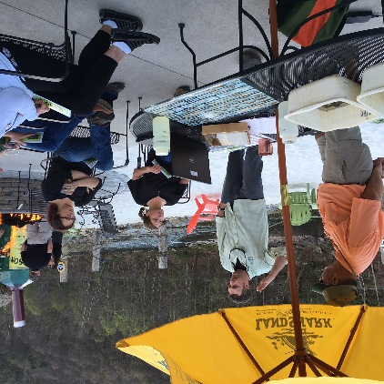

The Basic Structure of a 3-Hour Introduction to Fly Fishing
Set up 6 stations; Women divided into six groups; Rotate through stations every 30 minutes.

Stations:

- Casting
- Fly Tying
- Equipment (rod, reel, vest, waders, boots, etc.)
- Aquatic Insect Identification
- Knot Tying
- TU conservation mission information

Supplies Needed:

- Fly Rods (at least 4, with yarn on end of leader)
- Person with fly tying set-up to demonstrate how flies are made
- A variety of fishing equipment: waders, vests, boots, rod, reel, etc.
- Aquatic Insects – Photos plus life cycle pamphlet (from Fish & Boat), or real insects in water and ice cube trays for separating. Some artificial flies to demonstrate how they are made to replicate the stages of the insect.
- Fly line – best suited for practicing knot tying; two colors; PAF&B has a knot tying hand out or find one on line to copy. Direct women to you-tube videos or Orvis website.
- Hand-outs, video; a volunteer good at describing the TU mission and ways the women can get involved at the local level.
- Tables & chairs
- Snacks
- At least 8 volunteers; ideally, at least half of them female.

With any luck at all, your chapter members will have all the tools and equipment necessary to supply all of the above without costing your chapter a dime. PAF&B offers most handouts for free or you can print out needed copies from their website. They have a good bug chart as well as terrific handouts on the Mayfly, Caddis, and Stonefly life cycle.

Offer snacks (donated by a sponsor or supplied by the chapter) or hold the event at a restaurant or other venue where people can purchase their own drinks, have their friend or partner watch TV at the bar while the women learn, and/or where the whole family can meet up after the 3-hour event to enjoy dinner or lunch and learn more about TU! Try to ensure that the selected venue has room outside for, at a minimum, the casting station.

Example of a flier to advertise the event.
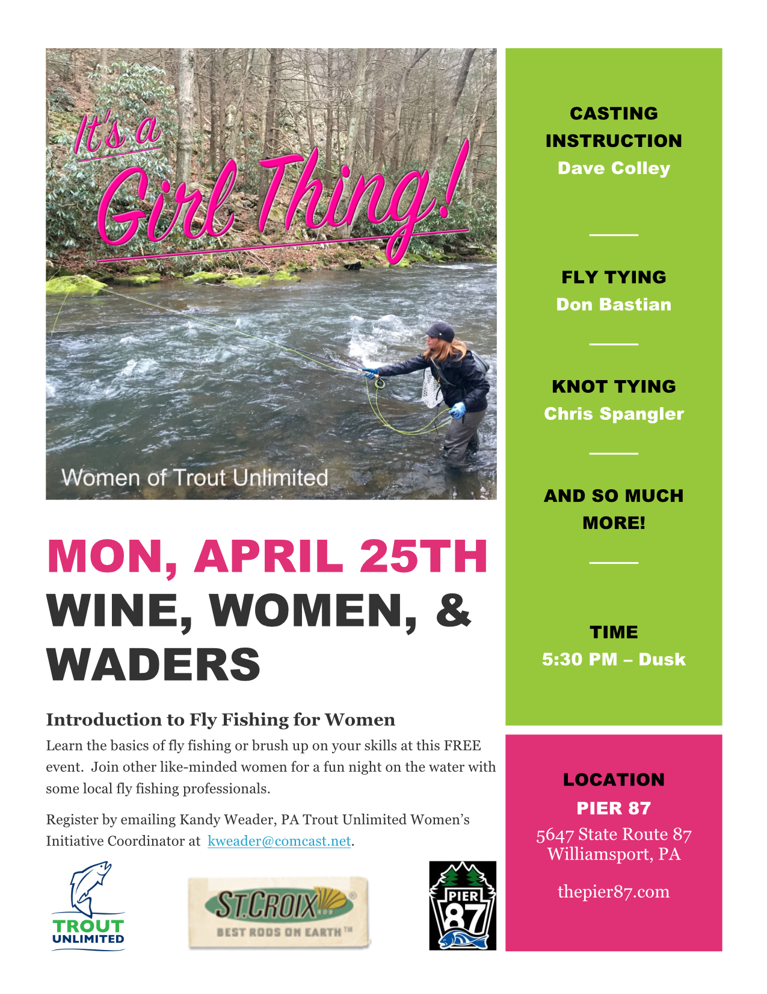
Other examples/templates can be viewed at www.tu.org. Create a flier on the Event Kits site.

Press Release Example
(Your chapter logo here)
FOR IMMEDIATE RELEASE (name)____ Women/Diversity Coordinator
Date _______ Chapter of Trout Unlimited
Town Phone #
e-mail

____________ Chapter of Trout Unlimited to Host a Women’s Introduction to Fly Fishing
An afternoon of learning, fun, and meeting like-minded women.

The ________ Chapter of Trout Unlimited will host An Afternoon of Learning to introduce women interested in finding out more about fly fishing. The 3-hour event will feature local fly fishing experts sharing their skills of fly fishing in our region as well as tips and techniques for catching trout and other species using flies and lures. Flies tied by local members of the local chapter will also be on display. Snacks will be served.

WHEN:
TIME:
WHERE:
WHO: Women of all ages who would like a basic introduction to fly fishing.

All equipment will be provided.
For more information about the ______ chapter visit our website at www.___________
The mission of __________ is to ______________

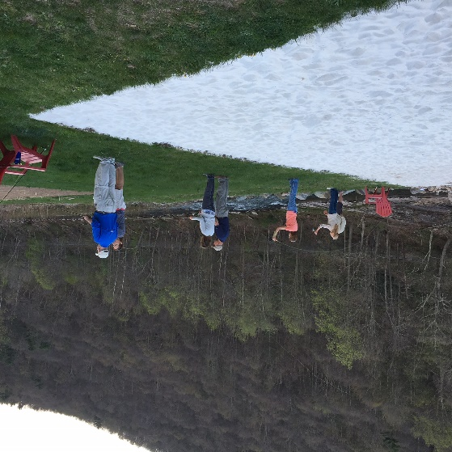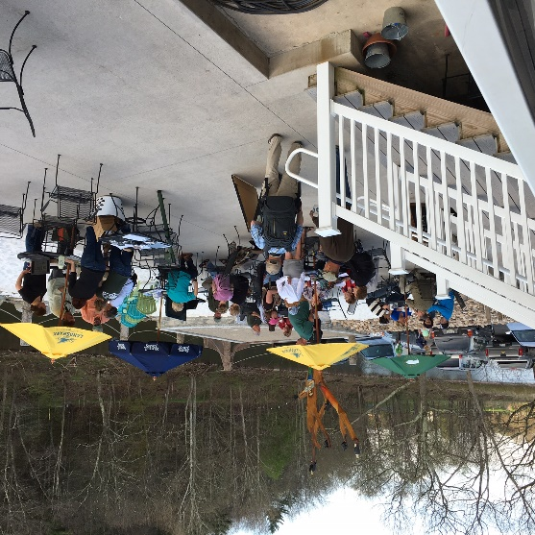

Add a footer with “the ____chapter of TU is a tax exempt 501(c) 3 non-profit organization.”
Take photos to use in continuing events and Facebook publicity.

(Your chapter logo here)

Photo Waiver Form

I hereby give the _______ Chapter to Trout Unlimited the right to use photographs, interviews and videos taken of my child this date for publishing, illustration, advertising, trade and promotion, or any other use in any medium for any purpose.

I release Trout Unlimited from any claims and demands arising out of the use of the photographs, interviews or videos. This release also covers legal representatives and any licensees of these photographs. I understand that photographs will be copyrighted in the name of Trout Unlimited and may be used in conjunction with other photographs, as part of a composite, or in any form whatsoever.

* * * * * * * * *
If the person is under 18 years of age, consent should be given by parent or guardian as follows:

I hereby certify that I am the parent or guardian of (please print student name)

______________________________________

For the student named above, and for value received, I do give my consent without reservations to the foregoing on behalf of him or her or them.

Signature of Parent or Guardian: __________________________ Date:__________________

Initial each item to which you are giving consent:

Photographs yes ______ no ______

Video yes ______ no ______

Interview on video yes ______ no ______

Witness (please print): ___________________________
Signature of Witness: ____________________________

Please return this completed form to:

__________ Chapter of Trout Unlimited
c/o (contact person)
Address

Thank you.

Women/Diversity Coordinator
e-mail address
phone #
add footer with your 501©3 status
Advertising Possibilities
Consider a wide variety of places to get the word out with flyers, posters, public announcements.

- Web sites like Meet-Up, Facebook, etc.
- Public Library
- Community Calendars
- The venue where you plan to hold the event (restaurant or community building)
- YMCA
- Health Centers
- Fitness Centers

Things to consider:

- Have one volunteer in charge of each station; it their responsibility to make sure they have everything needed for the station.
- Hang a TU chapter banner near the venue to let passers-by know who is hosting the event.
- Consider partnering with a Conservation group or other appropriate partner.
- Hand out information about TU and membership, for attendees to take home, along with knot tying materials/hand-outs, bug ID info, anything else to reinforce the event.
- Be sure to get all attendees to sign-in with name and contact information so you can start sending them your chapter’s newsletter.
- Have one volunteer “roam” the event, making sure everyone is comfortable, and take notes on anyone who might be showing interest in or asking about what more they can do with the chapter. Then Follow Up!

Follow-Up

- Thank you notes to donors, volunteers, partners (at least e-mail a thank you)
- Keep good contact information records to make follow up notes easy.
- Follow-up with any women who expressed or demonstrated interest in further participating in events to further the TU mission.
- Have a “de-briefing” with volunteers to discuss what worked, what could be improved. This debriefing could be done via e-mail or over beer at the local tavern.

Remember, this is an event to bring more women into the chapter’s activities and leadership, so be sure to sell your chapter’s conservation work. Women like to learn and they are often especially attracted to the conservation work.

Time Line

Give yourself at least two months to plan the event.

Weeks 1-4:

1 – Convene a planning committee of at least 3 people.
2 – Select a venue
3 – Search for and contact volunteers to work at each station. (Remember to seek out at least some women, if not all!)
4 – Assign one person to be in charge of each station. They list all materials needed and start arranging acquisition of those materials.
5 – Arrange for tables and chairs for the event.
6 – Design flier for the event. This should be ready distribute one month before the event.
7 – Line up your advertising/notices.
8 – Identify any partners or donors and what you will ask them to provide.
9 – Consider how you will request RSVP’s. Not always possible but desirable.

Weeks 5-8:

1 – Start advertising; put up fliers, notify radio, community calendar sites, Facebook.
2 – Send out Press Release two weeks before the event.
3 – Assign a chapter volunteer to take photos at the event. Remember, happy, smiling face shots are best for future advertising and media blasts about your success.
4 – Make an on-site visit to be sure you have figured out the placement of tables/stations.

Day of Event:

Get there early to set up. Have sign-in sheets ready with pens! One person should be in charge of signaling when groups change to next station. Give about 5-10 minutes to change and settle in to new station. Keep attitudes positive, fun, helpful.
Be sure you line up volunteers to help clean up after event.
Congratulate yourselves for putting on a very useful and appreciated event for your new group of potential women in TU!

