Introduction to Fishing “Event in a Box”
For Families and Individuals
4 – Hour Event

As we all know, Trout Unlimited is not a fly fishing club, it is a conservation organization. We also know that many individuals get involved with the TU conservation work because they are trout fishing men and women. Often what comes first is an interest in fishing, then comes the important interest in conserving the coldwater resource that sustains the trout population.

This “Event in a Box” is designed to introduce families and individuals to the sport of fishing. You can adapt this instruction to either fly fishing or bait fishing. Note that fly fishing requires plenty of space and caution if a large group of people are casting into water. It will also be important to include an introduction to the mission of Trout Unlimited during this event.

The following pages include ideas and suggestions for running a 4-hour introduction to fishing. Hopefully it will stimulate your own creativity in offering similar skill building events that not only introduce your community to fishing, but also introduce them to Trout Unlimited, to your TU chapter, and the good work your chapter does. You will also want to do membership recruitment and keep your eyes and ears open for people who could be potential leaders within your chapter.

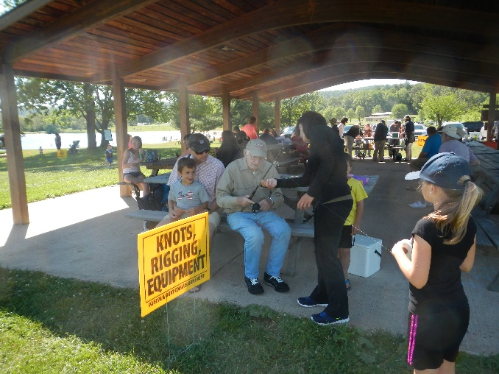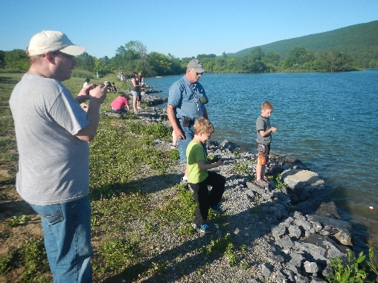

The Basic Structure of a 4 – Hour Introduction to Fishing
This structure includes one hour of fishing

Set up 5 stations; divide people into 5 groups; groups rotate through the stations.
Approximately 30 minute rotations, giving time to move from station to station. Approximately one hour is designated at the end of the group instruction for fishing.

Begin with addressing the entire group, explaining how the time will be allocated, then give a lively explanation of the Trout Unlimited mission, the reason for being a member, and your chapter’s activities and how they can get involved. Provide hand-outs to take home.

Stations:

- Rod Mechanics & Rigging
- Casting
- Knot tying & Equipment Description
- Stream Dynamics & Stream Health
- Aquatic Insect Instruction & Fish Behavior

Supplies Needed:

- Rods, reels, line, leader material, flies or bait; nippers, needle nose pliers, rags
- Hoola hoops & cardboard cut-out fish for targets when casting
- Large eye bolts or corks with a small eye bolt screwed into top, to replicate the eye of a fish hook.
- Two foot pieces of cotton cord or fly line or something to replicate leader that attaches to hook.
- PA F&B hand-out on knot tying.
- Examples of equipment needed to do the type of fishing you are teaching. E.g. waders and boots or tackle box and nippers, etc.
- Drawings or handouts or a long canvas roll out that shows runs, riffles, and pools.
- Hand-outs, small shrubs, anything that helps demonstrate the idea of deep rooted vegetation plus shade that is needed along a stream bank. An Enviroscape is a great tool for explaining how all rain and Stormwater runs to the stream and why riparian buffers are essential to a healthy stream. You may be able to borrow the Enviroscape from your local county conservation office.
- Aquatic insects collected from a nearby stream, or at least photos of common bugs found in your local streams. Ice cube trays to separate bugs.
- TU membership information, photos of what your chapter does to improve stream health.
Adjust the structure to fit your needs, your volunteer strengths, and the location. An ideal location might be a State park with a lake or adequate length of stream to spread out along. A pavilion with picnic tables and benches are helpful. Otherwise you must supply tables and chairs. Snacks and drinks are always a good thing to offer or tell attendees to bring their own snacks and drinks. Have at least 10 volunteers on hand. Depending on attendance, you will need plenty of volunteers to help during the fishing part of the event.

It can be helpful to assign one volunteer to each station. That person is in charge of obtaining and preparing all the supplies needed for that station, for teaching the subject matter, and clearing up afterwards.

Design a flier that can be hung up at fly shops and sporting goods stores, post offices, sent electronically to your members. Put out a Press Release.

Advertising Possibilities

Consider a wide variety of places to get the word out with flyers and public announcements.

- Web sites like Meet-Up, Facebook, etc.
- Public Library
- Community Calendars
- The venue where you plan to hold the event
- YMCA
- Health Centers like physician groups
- Fitness Centers

Things to Consider

- Hang a TU chapter banner near the venue to let passers-by know who is hosting the event.
- Consider partnering with another conservation group or other appropriate partner.
- Have bags ready for attendees to take home hand-outs.
- Get attendees to sign-in with name and contact information so that you can start sending them your chapter’s newsletter.
- Have one volunteer “roam” the event to make sure everyone is comfortable. Take notes on anyone who might be showing interest in or asking about what more they can do with the chapter. Then Follow Up! (There could be a potential future TU leader in the group.)
- Get donations of snacks, or materials, from local businesses.
- PA Fish & Boat has terrific hand-outs, and can give you a fishing license waiver for the event if one of you has a PA F&B instructors certificate.

Follow-Up

- Thank you notes to donors, volunteers, partners. (At least an e-mail to thank them.)
- Keep good contact information records to make follow up notes easy.
- Follow up with anyone who expressed more interest in TU.
- Have a “de-briefing” with volunteers to discuss what worked, what could be improved.
This could be done via e-mail, or over a beer at a local tavern.

Remember, this is an event to educate your community about the fun of fishing, coldwater conservation, and the benefits of being a member of Trout Unlimited. (Perhaps even an active chapter member.) Therefore, make it fun for everyone, keep it active and hands on, and don’t be shy about selling the mission of Trout Unlimited.

Time Line
Give yourself at least 2 months to plan this event and get the work out to the community.

Weeks 1 – 4:
- Convene a planning committee of at least 3 people
- Select a venue
- Search for and contact volunteers to work at each station and help with fishing.
- Design a flier for the event. Distribute at least month before the event.
- Line up advertising
- Identify partners or donors and what you will ask them to provide.

Weeks 5 – 8:
- Start advertising; put up fliers; notify radio, community calendars, Facebook.
- Send out Press Release two weeks before event.
- Assign a volunteer to take photos at the event. Happy, smiling face shots are best for future advertising and media blasts. (eliminate “butt” shots)
- Make an on-site visit to be sure you have placement of stations figured out.
Day of Event:
- Get there early to set up. Have table or clip boards ready for sign-in sheets with pens.
- One person should be in charge of timing and signal when groups change stations.
- Keep attitudes positive, helpful, fun.

The following pages are examples of a flier, a press release, and a photo waiver form. Other examples and templates for a flier can be viewed at www.tu.org. Create a flier on the Event Kits site.
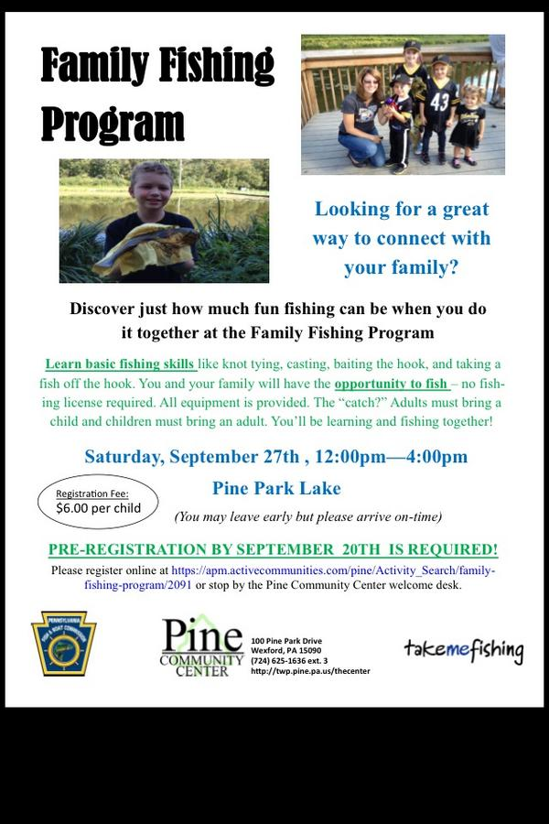
Press Release Example
A press release should include contact info., Headline and subhead, event summary, be clear, concise and tell What, Who, When, Where, Why, How. No more than one page.

Your Letterhead here

FOR IMMEDIATE RELEASE CONTACT INFORMATION
Date Name
Town President, _______ Chapter of TU
Address
Phone:
Introduction to Fishing Event
Learn how to (fish or bait fish), have some family fun, and get outdoors.
The ______ Chapter of Trout Unlimited (___TU) and ______ (Partner) will be inviting the community to an introduction to Fishing event. Families will __________________________ (describe your goals here).
Date
Time -
Location -
Address -
RSVP requested
___TU will teach families to fish. All equipment will be provided. No fishing license required for that day and location. The (partner) will be providing ……
For more information about the _______ Chapter of Trout Unlimited activities, visit their website at www.chaptertu.org
The mission of the ________ Chapter of Trout Unlimited is to conserve, protect, and restore _____________ coldwater fishery and watershed.

The __________Chapter of Trout Unlimited is a tax exempt 501(c) 3 non-profit organization.

You could add a photo of some previous event.

Your chapter logo here

Photo Waiver Form

I hereby give the ______ Chapter of Trout Unlimited the right to use photographs, interviews and videos taken of my child this date for publishing, illustration, advertising, trade and promotion, or any other use in any medium for any purpose.

I release Trout Unlimited from any claims and demands arising out of the use of the photographs, interviews or videos. This release also covers legal representatives and any licensees of these photographs. I understand that photographs will be copyrighted in the name of Trout Unlimited and may be used in conjunction with other photographs, as part of a composite, or in any form whatsoever.

* * * * * * * * *
If the person is under 18 years of age, consent should be given by parent or guardian as follows:

I hereby certify that I am the parent or guardian of (please print student name)

______________________________________

For the student named above, and for value received, I do give my consent without reservations to the foregoing on behalf of him or her or them.

Signature of Parent or Guardian: __________________________ Date:__________________

Initial each item to which you are giving consent:

Photographs yes ______ no ______

Video yes ______ no ______

Interview on video yes ______ no ______

Witness (please print): ___________________________

Signature of Witness: ____________________________

