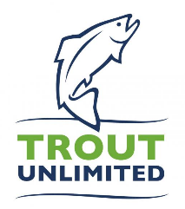

US Army Corps of Engineers Philadelphia District
Planning Division
100 Penn Square E.
Philadelphia, PA 19107

RE: Francis E Walter Dam Feasibility Re-Evaluation Study

Trout Unlimited, representing 14,000 members and 49 chapters in the Commonwealth of Pennsylvania, and more than 300,000 members and supporters nationally, is encouraged by the efforts of the Army Corps of Engineers, Delaware River Basin Commission, and New York City Department of Environmental Protection to consider necessary operational and/or structural changes to Francis E. Walter Dam. We recognize the importance of the Lehigh River to the outdoor recreation economy in Pennsylvania, which provides more than $29.1 billion in consumer spending and supports more than 250,000 jobs.

Through the hard work of many partners in the region, the Lehigh River has undergone an incredible transformation. Thanks to the cooperation between USACE, Pennsylvania Fish and Boat Commission, local fisheries groups, and the whitewater rafting community, a once lifeless river is now home to a thriving, yet fragile, wild trout population, due to improvements in water quality.

Trout Unlimited is thankful for the opportunity to file public comment regarding the Re-Evaluation study and requests the member parties take our below requests into consideration as this process moves forward.

- Any alterations to the dam and/or the flow management plan result in no net loss of fisheries enhancement release days and minimum flow restrictions as jointly agreed to by the fisheries and recreation stakeholder community and USACE annually since 2005. These conservation-minded releases enable coldwater storage at least into the beginning of summer. We have seen the benefits of these releases result in an increased population of wild trout and over-summer survival rates of stocked trout for anglers to enjoy throughout the year. The flow management plan has also provided a pathway for a $35 million outdoor recreation economy on the Lehigh River. Recognizing the importance of the Lehigh River to the local communities, we request that any outcome of the study result in no net loss in economic opportunity for local businesses and municipalities.

- The study should take a holistic approach and include an examination of potential negative impacts that any alterations to F.E.Walter might have to other fisheries in the basin, particularly the Upper Delaware River. We acknowledge New York City’s desire to detach from its obligations to release water to repel the salt front in the lower Delaware River; however, we see a potential threat to flow management in the Upper Delaware that may result in negative effects to the $400+ million annual outdoor recreation economy that is vital to this region.

- The current release tower at the F. E. Walter Dam is insufficient to maintain a year-round coldwater release, and thus restricts the potential for economic growth in the outdoor recreation economy of the Lehigh River, specifically the fishing economy. The release tower only has the capacity to draw water through a single gate at the bottom of the reservoir. As water is released throughout the year, the hypolimnion, or coldwater pool, becomes depleted in the spring and early summer (as seen in the graphic below).

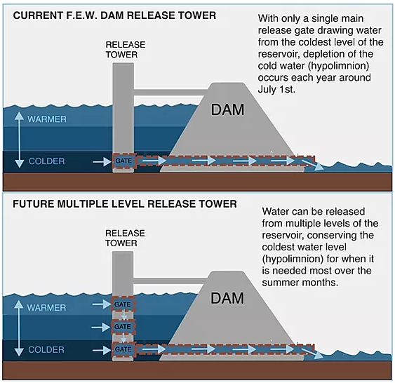
Graphic courtesy of Lehigh River Coldwater Fisheries Alliance

Authorizing the F. E. Walter Dam Re-Evaluation Study to investigate the ecological and economic benefits of structural changes to the release tower, thus allowing it to access and conserve cold water year-round through use of water from areas of different thermal characteristics, will increase the recreational fishing opportunities. Additionally, we request that USACE build upon its 1985 study, which shows no adverse effects to flood control and improvements to habitat for fish through structural changes and authorizing increases in maximum storage capacity.
- In 2009 and 2014, respectively, USACE undertook water quality studies to measure the ecological and economic impacts to both structural and operational improvements to F.E. Walter. Trout Unlimited requests these findings be taken into consideration, recognizing the achievable benefits to the coldwater ecosystem that these studies found possible.
- We request continued participation as a stakeholder in the future proceedings of the study by inclusion on workgroups and/or other stakeholder groups and look forward to working with the member parties involved to reach a mutually beneficial outcome. We also ask the member parties to provide regular and transparent updates to stakeholders and the general public about the proceedings of the study and additional opportunities to provide public comment.

Pennsylvania Trout Unlimited thanks the member parties for the opportunity to submit public comment on the Re-Evaluation Study and look forward to continued progress towards meeting the water needs in the Delaware River Basin. Please do not hesitate to reach out with any questions.

Sincerely,

Greg Malaska, President
Pennsylvania Council of Trout Unlimited

Brian Wagner, National Leadership Council Representative
Pennsylvania Council of Trout Unlimited

Jennifer Orr-Greene, Mid-Atlantic Policy Director
Trout Unlimited

Robert Shane, Mid-Atlantic Organizer
Trout Unlimited

