Pennsylvania Council of Trout Unlimited
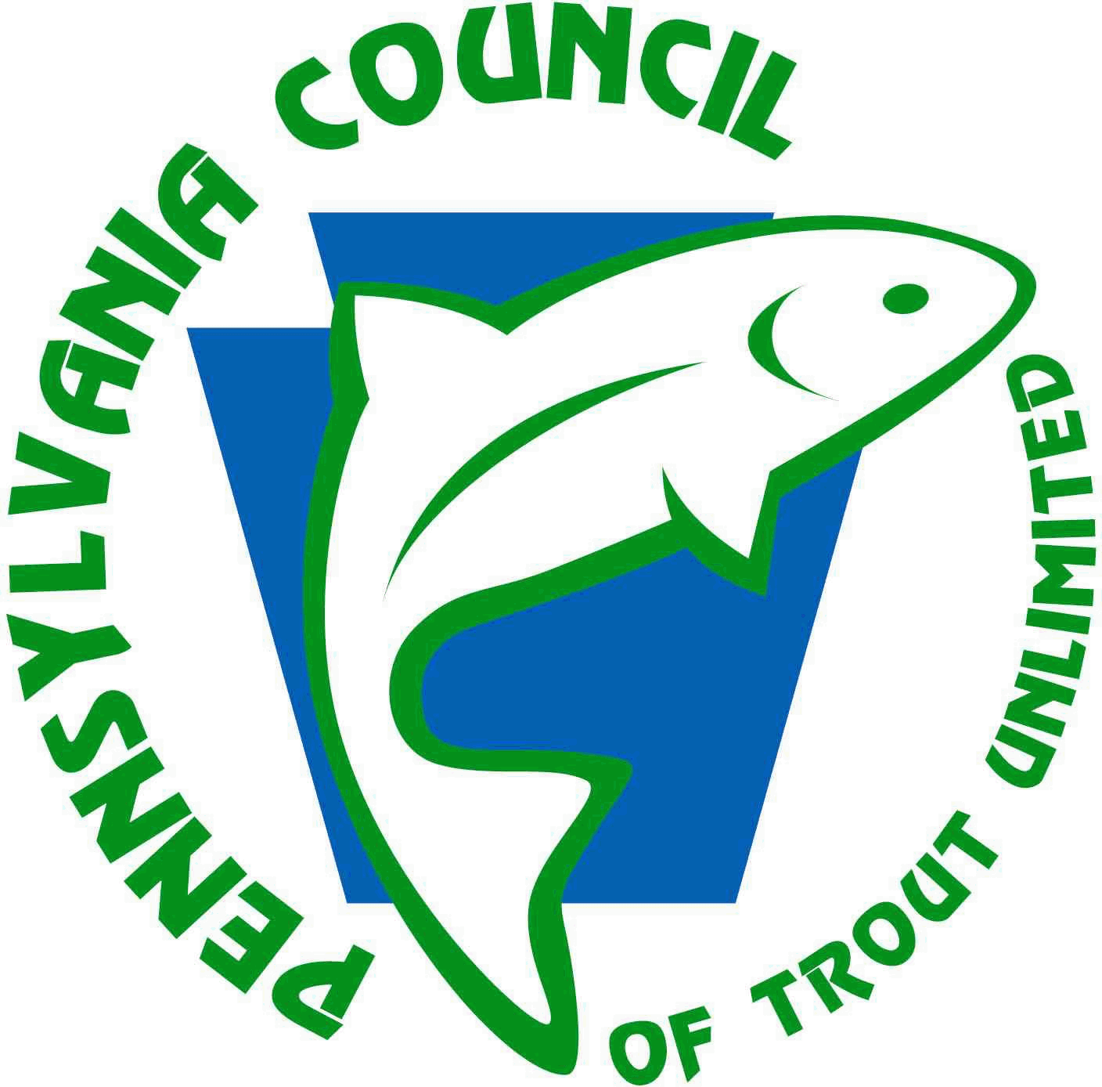
“Forever Wild” Mini Grant Program

All proposals should be submitted to:

Rachel Kester
c-rkester@pa.gov

or

PA Council of Trout Unlimited
Attn: Forever Wild Grant
PO Box 5148
Bellefonte, PA 16823

All mailed applications must be postmarked by
July 24, 2020 and emailed applications must be received by 4:00 PM EST.

Questions: Contact PATU Program Director Rachel Kester
814-359-5233
c-rkester@pa.gov

BACKGROUND
The Pennsylvania Council of Trout Unlimited (PATU) raises funds in a variety of ways including through the sale of merchandise (including the Back the Brookie license plate), its annual appeal, and by donations from anglers and conservationists and their friends and family to commemorate special occasions. To ensure that these funds are used to implement and further the mission of PATU, a small grant fund has been established for coldwater resource conservation, restoration, and education projects and initiatives. This grant program will award small grants to Trout Unlimited chapters in Pennsylvania to complete projects and programs that directly relate to the protection and restoration of Pennsylvania’s wild trout species and which further the objective of education and outreach to communities within the Commonwealth about the importance of our coldwater resources and their conservation.
PATU’S FOREVER WILD GRANTS
Purpose
Grants of up to $1500 will be awarded to eligible Pennsylvania Trout Unlimited chapters to assist with efforts to protect, conserve, restore and sustain wild trout populations and/or to carry out education and outreach programs that increase the awareness of and support for coldwater conservation among a non-TU audience. Preference will be given to projects supporting native brook trout populations, but projects supporting other wild trout populations will be considered.
Eligible Projects
The following list provides examples of projects eligible for funding. Other projects may be considered. Please contact PATU to inquire about your project proposal.
- In-stream habitat improvements to benefit wild trout
- Riparian buffer restoration along wild trout streams
- Streambank stabilization of wild trout waters
- Education and outreach programs and materials focused on coldwater resource conservation and/or restoration created for and presented to a non-TU audience, in addition to chapter members
- Sampling equipment for specific stream monitoring and survey projects
- Stream assessment or research projects
- Innovative trainings and leadership development initiatives that increase the internal capacity of the chapter to directly benefit coldwater resources
Other Project Requirements
- Proposed project must be completed, and final reports must be received within 1 year of final contract date and receipt of funds.
- Project must serve to protect, conserve, restore or sustain wild trout populations either through an on-the-ground implementation project or through increased awareness and understanding of threats to coldwater resources, streams, and watersheds and opportunities for conservation
  - Proposals that address brook trout habitat will receive greater consideration by the review committee, but projects that address all wild trout habitat will be considered.
- The TU chapter must take the lead in implementing the project and there must be significant involvement of TU volunteers in the project.
  - Though not a requirement, projects will receive greater consideration in the review process if they serve to:
    - Recruit new members
    - Engage more members in chapter activities
    - Develop new leaders
- Grant funds will be awarded via a check made out to the TU chapter and cannot be made out to any third-party contractor, consultant, or partner.
- Applicants must meet all the criteria for a viable chapter (see criteria checklist below).
All grantees will be required to complete an end of project summary that will be featured in the PA Trout newsletter and/or on the patrout.org website.
Ineligible Costs:

Grants cannot fund:
- Salary expenses for government agency personnel or non-profit staff who are project partners.
- Partially or fully completed projects that are seeking reimbursement for expenses.
- Travel expenses to conferences, meetings, events, or project work sites.

To Apply
To apply for a grant, please complete ALL the following steps:
- Contact PATU Program Director Rachel Kester to discuss the project and need for funding.
- Complete the following grant application. Boxes should expand as you type but feel free to attach additional pages if necessary.
- Verify that the chapter meets each of the eligibility requirements listed.

Applications may be submitted via email to c-rkester@pa.gov and must be received by 4:00 PM EST on July 24, 2020.

Mailed applications must be postmarked by July 24, 2020 and sent to:
PA Council of Trout Unlimited
Attn: Forever Wild Grant
PO Box 5148
Bellefonte, PA 16823

Grant Schedule
May 22, 2020 – Grant round opens
July 24, 2020 – Applications due via email by 4:00 PM or postmarked
August 2020 – Grants announced, award letters and grant assurances mailed to grant recipients
September 30, 2020 – Signed assurances due back to PATU
October 1, 2020 – Twelve-month project timeline begins
September 30, 2021 – Project end date, final report due

Pennsylvania Council of Trout Unlimited
“Forever Wild” Grant Application
Chapter Contact Information
Chapter Name:
Project Coordinator for Chapter:
Coordinator Address: | Phone Number:  Email:

Project Information
Project Title:
What is the focus of this project in terms of the coldwater resource?

Protect Reconnect Restore Sustain Educate
Stream Name: |  | PFBC Stream Classification:
Grant Request (up to $1500): | Matching Funds: |  | Total Project Cost:
Partners (Please list any partners and their roles in the project.):

Project Description: (Please provide detailed information about the project including project need, scope of work, deliverables or outcomes, how the project will benefit the coldwater resource, and how chapter volunteers and/or community members will be involved.)

Please describe how you will promote the project to chapter members, community members, the media, and others. (Consider options such as newsletters, websites, Facebook, and other social media outlets.)
Project Timeline (Please list each project task and its target date for completion):

Project Budget (Describe how the funds will be used and include all matching funds, cash and in-kind):

Chapter Eligibility Checklist

Please check ALL that apply to your chapter over the past two years:
Organized and participated in at least one restoration, enhancement, conservation or educational project;
Created or maintained a newsletter, website, email list-serve, or Facebook page to communicate with chapter members and the interested public;
Held regular meetings (at least 6 meetings/year, one being an annual meeting with elections);
Organized and executed at least one public activity that focuses on coldwater conservation, includes participation in a TIC event;
Held a yearly fundraiser (could include annual banquet, a 50/50 raffle, etc.);
Attended the PA Council Annual Fall Meeting;
Actively solicited or recruited new members;
Filed fiscal reports and CEI (Chapter Effectiveness Index) in a timely fashion (this must be done annually); and
Submitted quarterly reports to Council

