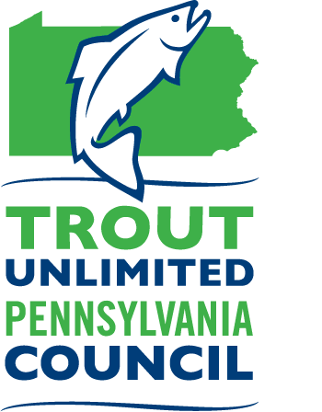
Pennsylvania Council of Trout Unlimited
Forever Wild Mini Grant Program

Background
The Pennsylvania Council of Trout Unlimited (PATU) raises funds in a variety of ways including through the sale of merchandise (including Back the Brookie license plates), its annual appeal, and by donations from anglers, conservationists, and their friends and family to commemorate special occasions. To ensure that these funds are used to implement and further the mission of PATU, a grant fund has been established to support coldwater resource conservation and education projects and initiatives. Through this grant program, small grants up to $2500 are awarded to Trout Unlimited chapters in Pennsylvania to implement programs and projects that directly relate to the protection and restoration of Pennsylvania’s wild trout species and educate the community on the importance of coldwater resource conservation.
Purpose
Grants of up to $2500 will be awarded to eligible Pennsylvania Trout Unlimited chapters to assist with efforts to protect, conserve, restore and sustain wild trout populations and/or to carry out education and outreach programs that increase the awareness of and support for coldwater conservation among a non-TU audience. Preference will be given to projects supporting native brook trout populations, but projects supporting other wild trout populations will be considered.
Eligible Projects
The following list provides examples of projects that are eligible for funding. Other projects may be considered. Please contact PATU to inquire about your project proposal.
- In-stream habitat improvements to benefit wild trout
- Riparian buffer restoration along wild trout streams
- Streambank stabilization of wild trout waters
- Education, outreach, and training programs and materials focused on coldwater resource conservation which are designed to educate the public, engage new members, and increase chapter capacity
- Sampling equipment for specific stream monitoring and survey projects
- Stream assessment or research projects

Additional Information
The Forever Wild program accepts applications year-round. Eligible projects will be awarded on a first come, first served basis until funds are depleted each fiscal year. Approximately $10,000-15,000 will be available annually.
- Grant funds will be awarded via a check made out to the TU chapter and cannot be made out to any third-party contractor, consultant, or partner.
- Proposed projects must be completed within one year from the date the award check is issued.
- Chapters must complete a final report (See attachment A) upon completion of the grant which includes a brief summary of the project and pictures suitable for publication in the PA Trout newsletter and on the PATU website and/or social media accounts.
- Projects must serve to protect, conserve, restore or sustain wild trout populations either through an on-the-ground implementation project or through increased awareness and understanding of threats to coldwater resources and opportunities for conservation.
  - Proposals that address brook trout habitat will receive greater consideration by the review committee, but projects that address any wild trout habitat will be considered.
- Partnerships are highly encouraged; however, chapter volunteers should play a significant role in the project.
- To be eligible for funding, chapter MUST regularly submit quarterly reports to Council and must submit their Annual Financial Report (AFR) on time.
- Matching funds (cash or in-kind) are encouraged but not required.

Ineligible Costs:

Grants cannot be used to:
- Pay for non-TU salary or travel expenses.
- Reimburse expenses for projects that have already been completed.

To Apply
To apply for a grant, please complete ALL the following steps:
- Contact PATU Program Director Rachel Kester to discuss the project and need for funding.
  - Email: c-rkester@pa.gov
  - Phone: 814-359-5233
- Complete the following grant application. Boxes should expand as you type but feel free to attach additional pages if necessary.
- Verify that the chapter meets each of the eligibility requirements listed.
- Submit your completed application via email to c-rkester@pa.gov.

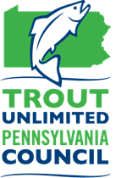
Pennsylvania Council of Trout Unlimited
Forever Wild Grant Application
Chapter Contact Information
Chapter Name:
Project Coordinator for Chapter:
Chapter Address: | Coordinator Phone Number:  Coordinator Email:

Project Information
Project Title:
What is the focus of this project in terms of the coldwater resource?

Protect Reconnect Restore Sustain Educate
Stream Name: |  | PFBC Stream Classification:
Grant Request (up to $2500): | Matching Funds: |  | Total Project Cost:
Project Summary (Using two to three sentences, briefly describe your proposed project.):

Project Need (Describe the problem or need the project will address and why funding is necessary.):

Scope of Work (Describe the work to be undertaken to complete your proposed project.):

Deliverables/Outcomes (Describe the intended measurable results of your project, i.e. 200 trees planted, three habitat structures constructed, 500 feet of streambank stabilized, fifty people educated, etc.):

Community Engagement (Describe how chapter volunteers and/or community members will be involved.):

Partners (Please list any partners and their roles in the project):

Please describe how you will promote the project to chapter members, community members, the media, and others. (Consider options such as newsletters, websites, Facebook, and other social media outlets.)
Project Timeline (Please list each project task and its target date for completion):

Project Budget (Describe how the funds will be used and include all matching funds, cash and in-kind):

Attachment A: Forever Wild Final Report
Chapter Name:
Project Title:
Name of Person Completing this Report:
Grant Amount: | Matching Funds: | Project Total:

In one to two paragraphs, please describe your project including stream and county, partners, what was done, and how the project will benefit the stream, trout fishery, and/or local community. This will be used in PATU publications and social media posts, so please make sure it paints a good picture of the project for folks who are unfamiliar with your work.

Please list below how your chapter spent their Forever Wild funding. Receipts are not required to be submitted, but please keep them in your grant file in case of audit.

Please attach a few high-resolution photos (JPG or PNG files only) that would be suitable for print or web publication. Make sure to include a caption and photo credit for each photograph. Before and after photos should be taken from the same vantage point. Choose photos that are visually compelling and tell the story of your project. If they are too large to attach to your email, contact the program director for sharing options.

This final report form and any attachments should be sent via email to c-rkester@pa.gov. Questions can be sent to Rachel Kester at the same address.

